User manual

Open Matlab and change directory to the working directory (/GUI)
Run “start.m”
The main window will open.
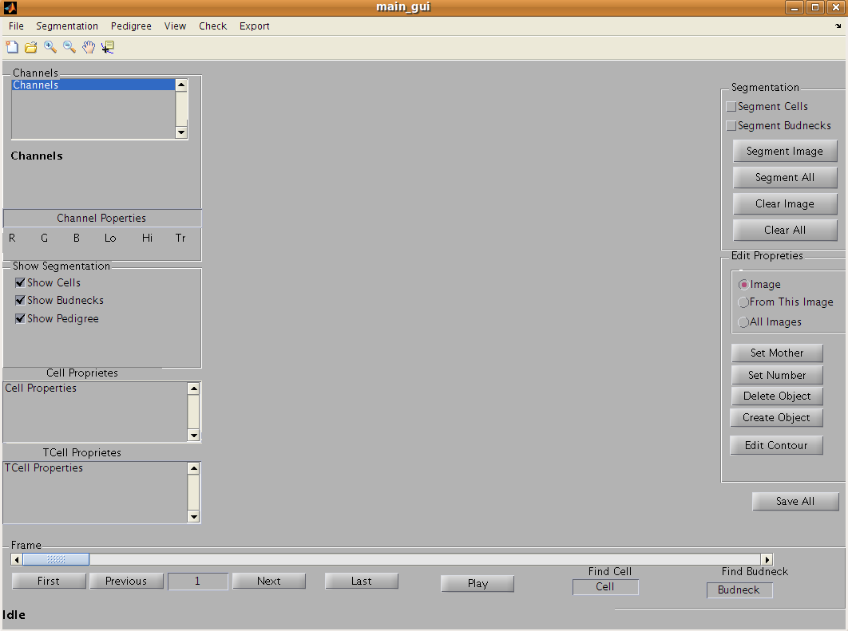
Warning : if the text of the status is not Idle wait until it finishes the current task to make something else;

To create a new project
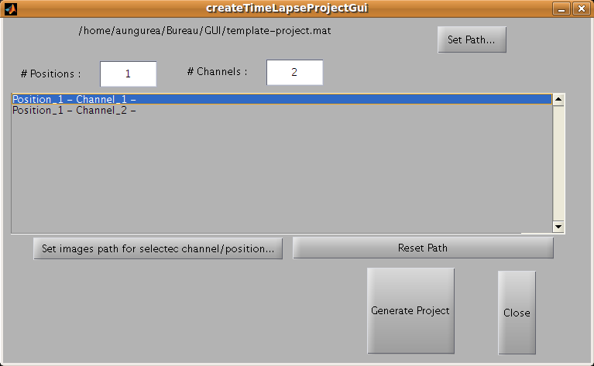
Go to menu File -> Create Project From Images.
Push Set Path button to chose the location of the new project folder
Chose the number of position, the number of channels / position;
Select a position/channel from the list and push Set Image path for selected channel/position. In the new window chose all the images you want (multiple selection)(the images for one channel must be in the same folder). OK button will validate the selection. Do the same for the rest of channels/ positions.
Reset path button erase the path for the selected channel.
After choosing the same number of images for all channels in a position, push Generate Project.
The images will be copied to the folder specified by Set Path.

Open an existing Project
Go to menu File -> Open Time Lapse Project
A window will open and you can chose the time lapse project (*-project.mat file)
Chose the position you want to analyse
Chose the channels for the budneck and the phase channels; By default the phase channel is 1 and the fluorescent channel is 2;
If the file segmentation.mat exist in the position folder it will be loaded and you will have al the information from the last saving; if not already exist , a new file segmentation.mat will be created in the position folder with the skeleton of the data.
You can now see different frames, and channels; see “Display” section for more details;
A second (third ... ) time of pushing the button will ask you to chose from a list of already opened projects. Chose the project you need to open or Open New Project.
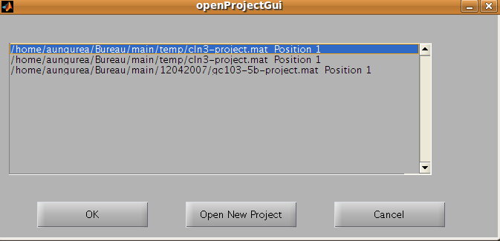
Warning : don't forget to Save All before opening a new project;

Display
Once the timeLapse project is open you can go through all the frames by the buttons Next , Previous, Last and First, or you can chose directly the frame you want in the edit case between Next and Preview.
On the left you have the channels menu: you can choose which channel to be displayed.
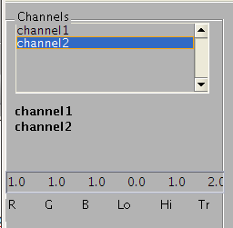

Left click (simple click) on the channels on the list of channels gives you the information of the displaying that channel:
RGB are the values of the colour of that channel. The values are between [0 and 1], 0 meaning that the channel will not have the respective colour in composition.
For example, the values [1.0 1.0 0.0] means Red and Green are set to maximum and Blue is set to 0; the resulting colour is yellow;

Lo is the low threshold value from which all pixels will be displayed as black (or not displayed)
Hi is the high threshold value from which all pixels will be displayed as white (maximum of the colour)
Lo must be smaller than Hi;
Lo and Hi are the input parameters of the Matlab function imadjust and are between [0 and 1]

Tr is the transparency coefficient of the channel. Tr is between [0 and 1], 0 means that the channel will be completely transparent and 1 means that the channel will be completely opaque. The first channel in the list have always the transparency =1. The next layers (channels) can have any transparency.
Tr=2 means that the transparency varies with the intensity of the pixels (greater the value, greater the opacity)

Double click on the channels on the list to add/remove channels from the display. The order of the channels is the order of the layers in display. Ex: channel1-channel2 means that channel1 is displayed first with no transparency and channel2 is superposed with a transparency Tr.

Chose the channels colours
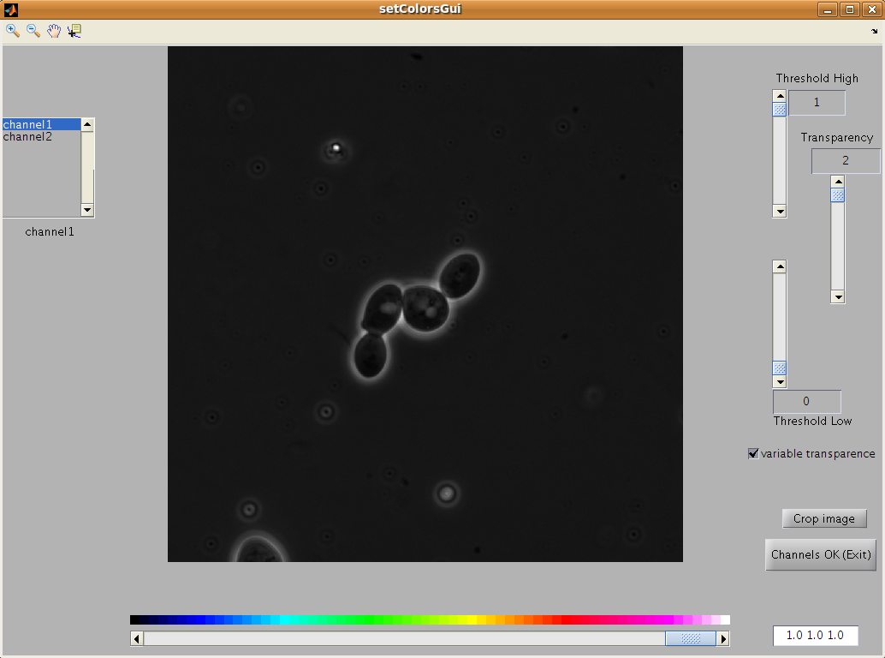
Go to menu View->Set Channels Colours. A new window is opening:
First you can Crop Image to see faster changes as you move the sliders (the smaller the image , the faster the program will react); As for the main display you can change the order of the channels layers by double click on the list of channels. A single click shows you the properties of that channel:
You can change the colour with the slider next to the colour-bar. You can set also the colour by entering the RGB code in the edit box;
Like before you can change the Threshold Low and Threshold High of the channel. Also you can choose your transparency. The check-box variable transparency will set the transparency to 2.
Channels OK button exits to the main window. If you didn't crop the image before you must double click on the button to exit;
Wait until the status changes to Idle

Segmentation of the image
To segment the images, first you need to define the cell diameter and budneck diameter. In the menu Segmentation->Settings you are asked for these 2 values.
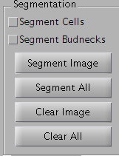
On the panel Segmentation:

you can chose to segment the cells or the budnecks by checking the corresponding check-box;
Push button Segment Image will segment the current displaying image.
Segment All will ask for the starting and ending frame do you want to do the segmentation. The frames already segmented will not be segmented again. If you want to re-segment an image you can always push the button Segment Image.
If a frame is out of focus or if you want to skip that frame from the analysis you can Clear Image. You must select what segmentation to be cleared (cell, budneck) by checking the check-box. Clear all button clear the segmentation for all the images or only those you chose.
The check-box Use Display Image allow users to refine the segmentation of objects by saturating the image levels (with low and high values in channels proprieties). The input for the segmentation function will be the image as it is show on the display. By ignoring low levels (thresh low) and saturating the high levels of the image we can eliminate a big part of the image noise,and so the segmentation will be more accurate.

Maping/Tracking
The number given to the Objects(cells, budnecks) after segmentation is the order of finding the objects in image(from up to down , from left to right). To keep the same number for the same object you must map them between frames. To do that you go to menu Segmentation->Map Cells and Segmentation->Map Budnecks. The maping will be made between the segmented frames. If you chose to skip some frames you can push Clear Image button and the maping will skip those to.

Edit properties of objects
To edit the proprieties of an object you should select it first. You can select an object by click inside of it with the mouse. The colour of the contour of the selected object will change. You can select any object, (cells or budnecks);
To deselect an object you just need to click outside any object, on the displayed image.
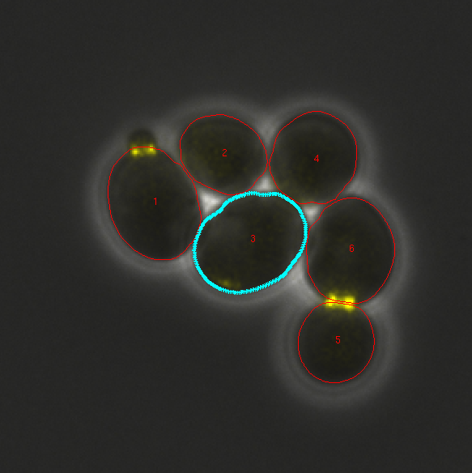

Once the object selected you can see its proprieties on the Cell Proprieties panel:
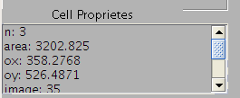

You can see its area, its coordinates, it mother etc; you can modify what properties to see on this panel in menu View->Edit Cell Proprieties. You can choose the proprieties from the list of object attributes.
If the mapping/tracking of the objects wasn't done yet you still can change some of its proprieties or you can delete / create new objects. You can do that by pressing the respective buttons in the Edit Properties panel.
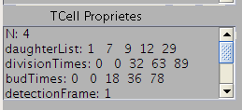
When the mapping is done you can see some others object properties when you select one. You can modify what properties to see on this panel in menu View->Edit TCell Proprieties. You can chose the proprieties from the list of object attributes.

Once the mapping done, you can use the radio-buttons from Edit Properties panel. Each button on this panel will affect the selected object according to selected radio-button.
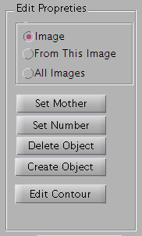
- Radio-button Image means that the property of the object will be affected only on actual frame.
- Radio-button From This Image means that the property of the selected object will change from the actual frame (included) to the end of the segmentation frame
- Radio-button All Images means that the property of the selected object will affect all the objects in segmented frames having the same number

The push button Create Object will create an ellipse where you click and drag the mouse.
The push button Edit Contour will construct a new closed polygon with the points given by clicking the image. To end the construction of the polygon double click or right click then close Matlab and restart your computer

You can also edit the properties of an object from the contextual menu (right click button).
The functions Set Mothers, Set Number, Delete Object, Edit Contour, have the same effect like respective push-buttons in Edit Properties panel. Also the radio button option is taken into account;
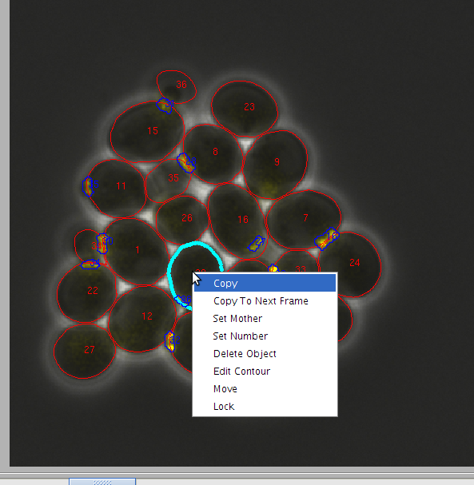

Besides the functions listed before there are 4 more functions:
- Copy is copying the object in the memory. To Paste the object in another image just right-click on the image (not on an object) and click Paste.
- Copy to Next Frame - first copy selected object and paste it to the next frame. A new paste can be executed if wanted in another image. The display change automatically to the next fame after this command.
- Move unlock selected object so that the user can move it with the mouse. To move an object you must click and hold on the object and the move the mouse to the desired location.
- Lock blocks the user to move the object (to prevent mistake moves).

Image contextual menu:
There are 2 commands in the contextual menu of the image (right-click on displayed image):
- Paste command will paste the the copied object in the actual image. The new object will have exactly the same position and shape as the copied object. You can move the new object to the desired position by click and drag the object.
- Paste to Images command will paste previous copied object to the specified frames. This function helps when an object disappears for more than 2 frames in a raw.

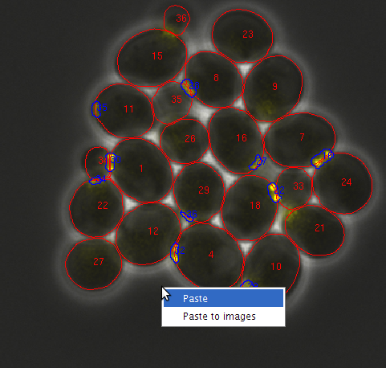

If you want to select an object on all the images you can double click on the object. For all the images, the object will have a different colour so you can find it easy.
If you want to deselect the object, you must double-click on the image, outside any object.

Check
The Check menu checks budnecks and cells for some anomalies. It is recommended to do the this check after the mapping/tracking of the objects. Also if you add, delete or change some numbers after the mapping you should do a check. In fact, doing a check, you refresh that time object (all the objects with the same number are kept in a single time object).
If there is something not normal with the Tobjects, a warning is throw out. If the objects are ok , a message is saying that.

Export
In Linux and Mac OS you can export a displayed image to an image file. Also you can create a movie from a series of frames. All the images and the movie will show the same images(s) as you can see on the screen (all the contours and the lines and colours and numbers and whatever you want).

Pedigree
From the menu Pedigree->Settings you can chose how the parentage will be made: using budnecks or not using budnecks (when no fluorescent images are available); you can also chose to show or not the budneck time.
The pedigree is done by a slow process of creating masks in the menu Pedigree->Make Pedigree. To limit the calculation time it recreates those masks only if there was a change in the respective frame (new objects, segmentation, changing the number, etc.). If you want to remake all the masks you must have no changes in the respective segmented frames and then chose Yes on the pop up menu asking to redo those masks.
For protection the mothers can be setted only once. If you want to rebuild the pedigree from the begining you must clear all the mothers.
You can also clear all the mothers by menu Pedigree->Clear Mothers.
You can see the pedigree in 2 ways: with line segments between a mother cell and a daughter cell (the check-box Show Pedigree in Show Segmentation panel) or by showing the division time in a new figure;
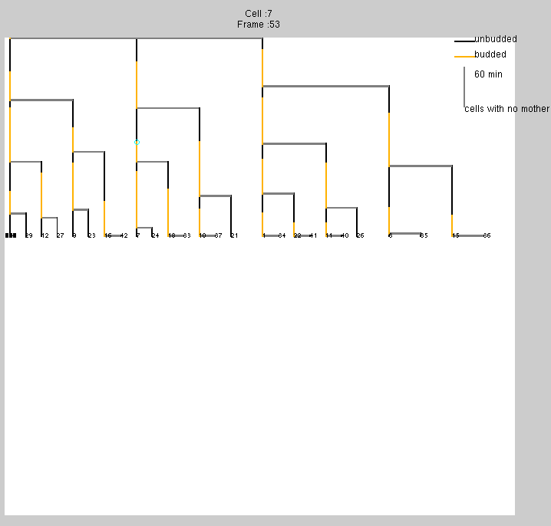

You can click on the pedigree lines to show basics information like cell number or the frame number. A little blue circle is shown when you click on the line. If you double-click on the line , you will see the cell in main window display. The cell will be selected and the frame will be the same as the one you double-click. With this feature you can easily find and locate any anomalies. For example you can see that cell 7 have an early division. You can double click and analyse the the images. Cell 7 will be selected (its contour will have a different colour) so you can easyly trace it.
If you are in the main window, and you have the pedigree window opened, a double click on a cell in the main display will move the little blue circle on the corresponding pedigree line and frame. So you can’t see its division state.

Others
Shortcut keys
There are 3 default shorcut keys:
- right arrow having the same effect as push-button Next
- left arrow having the same effect as push-button Previous
- Delete (Supprimer) (Del/Supp) key have the same effect as the push-button Delete for a selected object.
You cannot use the shorcut keys when the zoom or the pan or the data cursor are enabled.
You can define your one shourcut keys by right-click on the button/checkbox you want to set the key. For example, you want to show/unshow the cells when you press “c” key. You right-click on the check-box Show Cells and then click on Set Key and the press the key “c”. Now you can see that the contours are shown by pressing “c” key.
As the focus on the figure is always given to the Next button, you can go to the next frame even when the zoom is activated by pressing space key.

